**LAB REPORT: Motor Control**

Brandon Ackerman – RBT173

**Introduction**

For this laboratory, we are tasked with creating a circuit that will control two motors and formulate a program that will allow the control of the motors through directional commands in the code. Using the L293 chip to act as our driver, power signals are sent through the analogWrite() command to the enable pins, which enables the motors to function. The speed of the motors can be modified directly with the value assigned to the enable pins. The input pins are used to determine the direction the motors spin through the use of HIGH and LOW commands.

The circuit for this project is composed of the Arduino Uno platform, two motors, the L293 motor driver chip, and a separate power supply to feed the motors.

**Implementation**

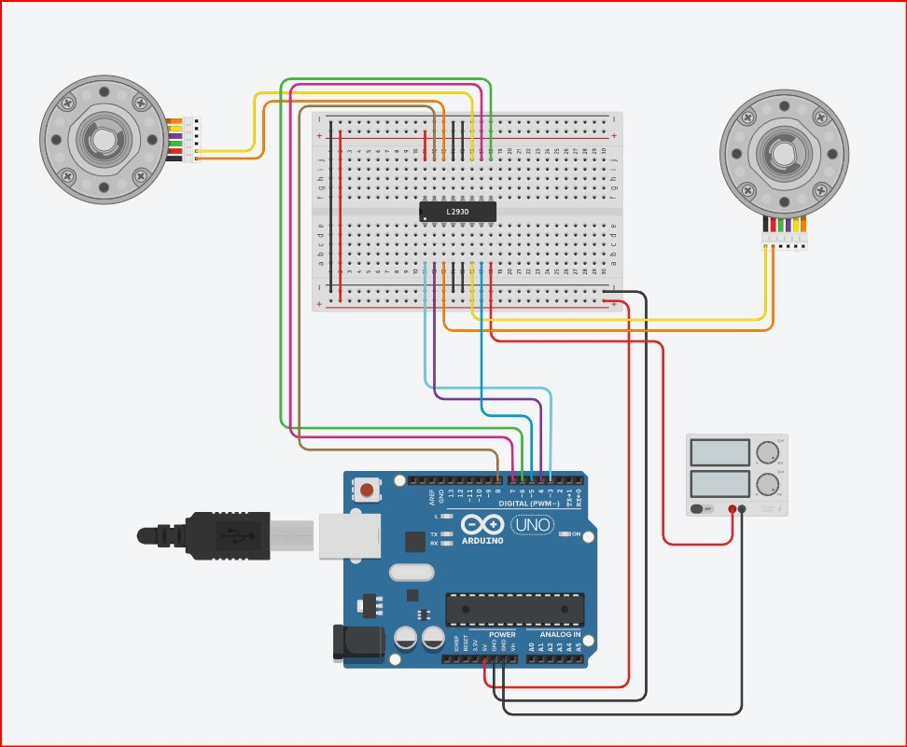

MOTOR CONTROL CIRCUIT

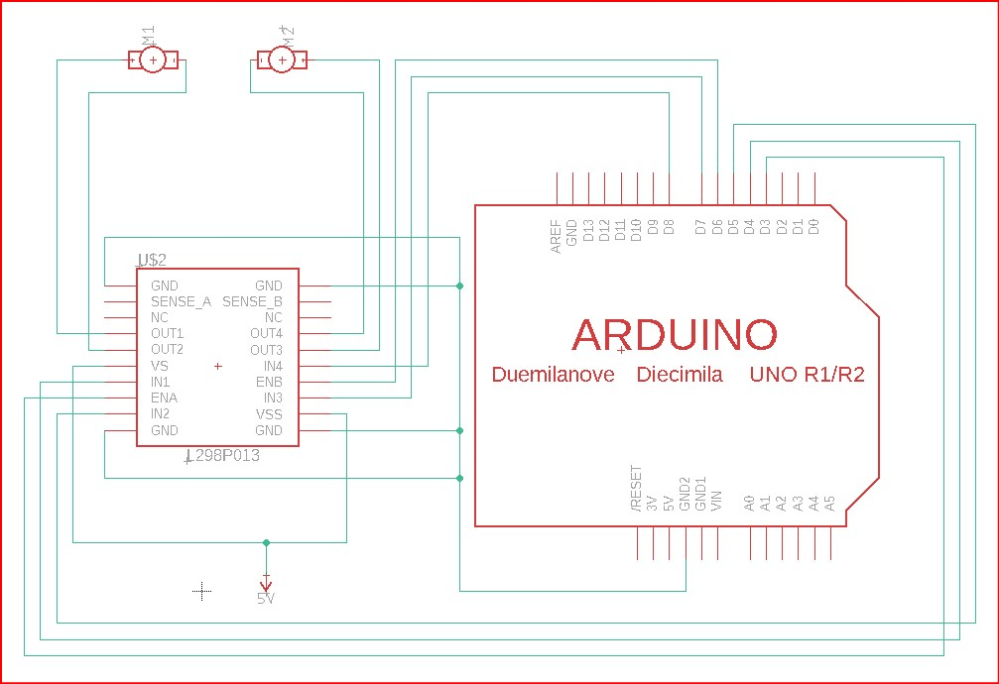

MOTOR CONTROL DIAGRAM

[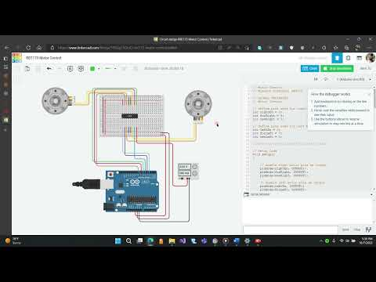](https://www.youtube.com/embed/235VxGvvseg?feature=oembed)

MOTOR CONTROL VIDEO

*// Motor Control*

*// Brandon Ackerman, RBT173*

*// GLOBAL VARIABLES*

*// Motor Control*

*// define pins used for right motor control*

*int* *rightEn* *=* 3;

*int* *forRight* *=* 4;

*int* *revRight* *=* 5;

*// define pins used for left Motor Control*

*int* *leftEn* *=* 6;

*int* *forLeft* *=* 7;

*int* *revLeft* *=* 8;

*////////////////////////////////////////*

*// Setup Code*

*void* *setup*()

{

*// enable right motor pins as output*

*pinMode*(*rightEn*, OUTPUT);

*pinMode*(*forRight*, OUTPUT);

*pinMode*(*revRight*, OUTPUT);

*// enable left motor pins as output*

*pinMode*(*leftEn*, OUTPUT);

*pinMode*(*forLeft*, OUTPUT);

*pinMode*(*revLeft*, OUTPUT);

}

*// Main Code*

*void* *loop*()

{

*// function commands for driving the motors*

*// Set motor speed to maximum*

*analogWrite*(*rightEn*, 255); *// enable right motor*

*analogWrite*(*leftEn*, 255); *// enable left motor*

*// Drive*

*forward*(); *// drive forward*

*delay*(1000); *// Wait for 1000 millisecond(s)*

*reverse*(); *// drive backwards*

*delay*(1000); *// Wait for 1000 millisecond(s)*

*// Reduce motor speed to half*

*analogWrite*(*rightEn*, 128);

*analogWrite*(*leftEn*, 128);

*forward*(); *// drive forward*

*delay*(1000); *// Wait for 1000 millisecond(s)*

*rightTurn*(); *// turn right*

*delay*(1000); *// Wait for 1000 millisecond(s)*

*forward*(); *// drive forward*

*delay*(1000); *// Wait for 1000 millisecond(s)*

*leftTurn*(); *// turn left*

*delay*(1000); *// Wait for 1000 millisecond(s)*

*reverse*(); *// drive backwards*

*delay*(1000); *// Wait for 1000 millisecond(s)*

*// Increase motor speed to 100%*

*analogWrite*(*rightEn*, 255);

*analogWrite*(*leftEn*, 255);

*leftSpin*(); *// spin left*

*delay*(1000); *// Wait for 1000 millisecond(s)*

*reverse*(); *// drive backwards*

*delay*(1000); *// Wait for 1000 millisecond(s)*

*rightSpin*() *// spin right*

*delay*(1000); *// Wait for 1000 millisecond(s)*

}

*// SUB-FUNCTIONS*

*//*

*// Right Motor Forward*

*void* *rightFor*()

{

*digitalWrite*(*revRight*, LOW);

*digitalWrite*(*forRight*, HIGH);

}

*// Right Motor Reverse*

*void* *rightRev*()

{

*digitalWrite*(*revRight*, HIGH);

*digitalWrite*(*forRight*, LOW);

}

*// Left Motor Forward*

*void* *leftFor*()

{

*digitalWrite*(*revLeft*, LOW);

*digitalWrite*(*forLeft*, HIGH);

}

*// Left Motor Reverse*

*void* *leftRev*()

{

*digitalWrite*(*revLeft*, HIGH);

*digitalWrite*(*forLeft*, LOW);

}

*// MAIN FUNCTIONS*

*//*

*//  Drive Forward*

*void* *forward*()

{

*rightFor*();

*leftFor*();

}

*// Drive Backwards*

*void* *reverse*()

{

*rightRev*();

*leftRev*();

}

*// Turn Right*

*void* *rightTurn*()

{

*// rightRev();*

*leftFor*();

}

*// Turn Left*

*void* *leftTurn*()

{

*rightFor*();

*// leftRev();*

}

*// Spin Left*

*void* *leftSpin*()

{

*rightFor*();

*leftRev*();

}

*// Spin Right*

*void* *rightSpin*()

{

*leftFor*();

*rightRev*();

}